Future Academy
Computer Science Department

Artificial Intelligence
Fourth Year First Semester

Time: 2 hours January 2007

Answer all questions
  - For propositional expressions P, Q and R prove that:
- (P Q) (P → Q).
- (P → Q) (Q → P).
- (P Q) (P → Q).
- P (Q ^ R) (P Q) ^ (P R)

- Represent the following English sentences in predicate calculus:
- If it doesn’t rain on Friday we will go to the park.
- Emma is a Doberman pinscher and a good dog
- All basketball players are tall.
- Nobody likes taxes.

- For the following term, give the output tree of the unification if it unify or else explain why unification would fail:
Unify ((parents X (father X) (mother sami)), (parents sami (father sami) Y))

- Given the following
- if it is sunny and it is warm, then Bill is happy.
- if there is blue sky then it is sunny.
- there is blue sky.
- it is warm.
- is Bill happy?
Use resolution to show Bill is happy

- build a finite state acceptor and transition matrix that recognizes the following:
- All strings of characters from the alphabet {a,b,c,d} that contain the exact sequence “abc”.
- All strings of binary digits{0,1} that contain the exact sequence “111”.
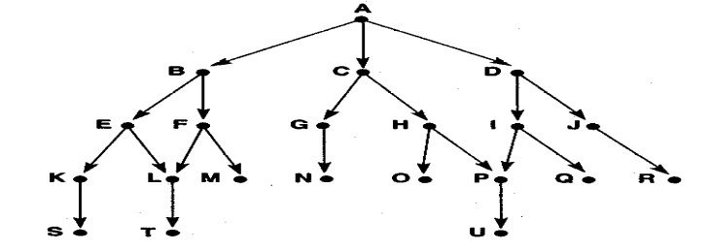
Write and trace the algorithms of Depth-first and Breadth-First search by using this graph.

- a) List some functions of Natural Language Processing.
b) What are the problems of the Natural Language Processing?
c) Why we use the Tokenization in the Natural Language Processing?
d) Compare between the Inflection and the Derivation in the Morphology.

Good Luck

